RESULTS

DATASET LINK
Dataset link

DASHBOARD LINK
https://public.tableau.com/views/mydashboard_17509169621120/Dashboard1?:l anguage=enUS&publish=yes&:sid=&:redirect=auth&:display_count=n&:origin =viz_share_link

STORY LINK
https://public.tableau.com/shared/2XJM9PZWS?:display_count=n&:origin=viz _share_link

GUIDED PROJECT LINK
https://apsche.smartinternz.com/Student/guided_project_info/70205#

INTERNSHIP LINK
https://apsche.smartinternz.com/Student/externships_workspace_info/86906

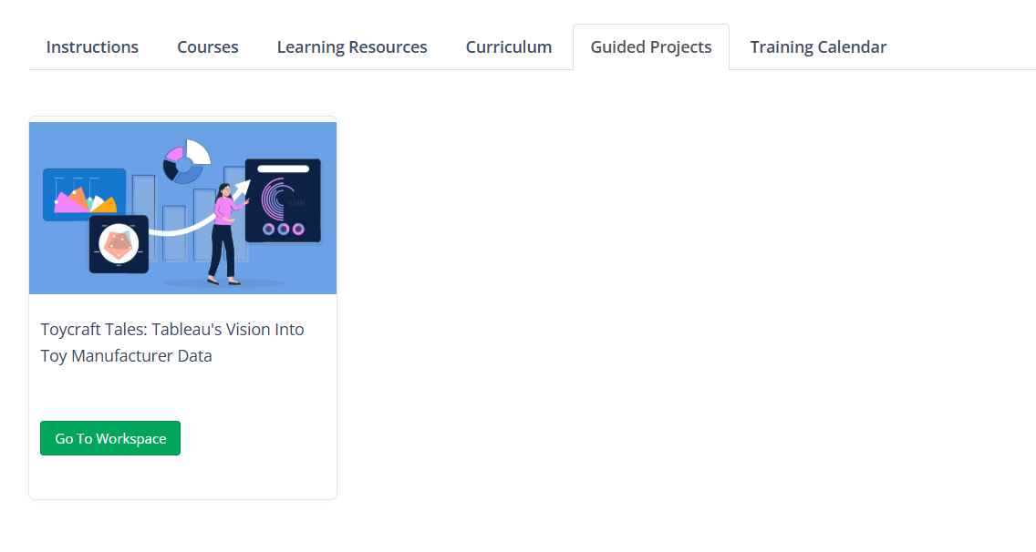

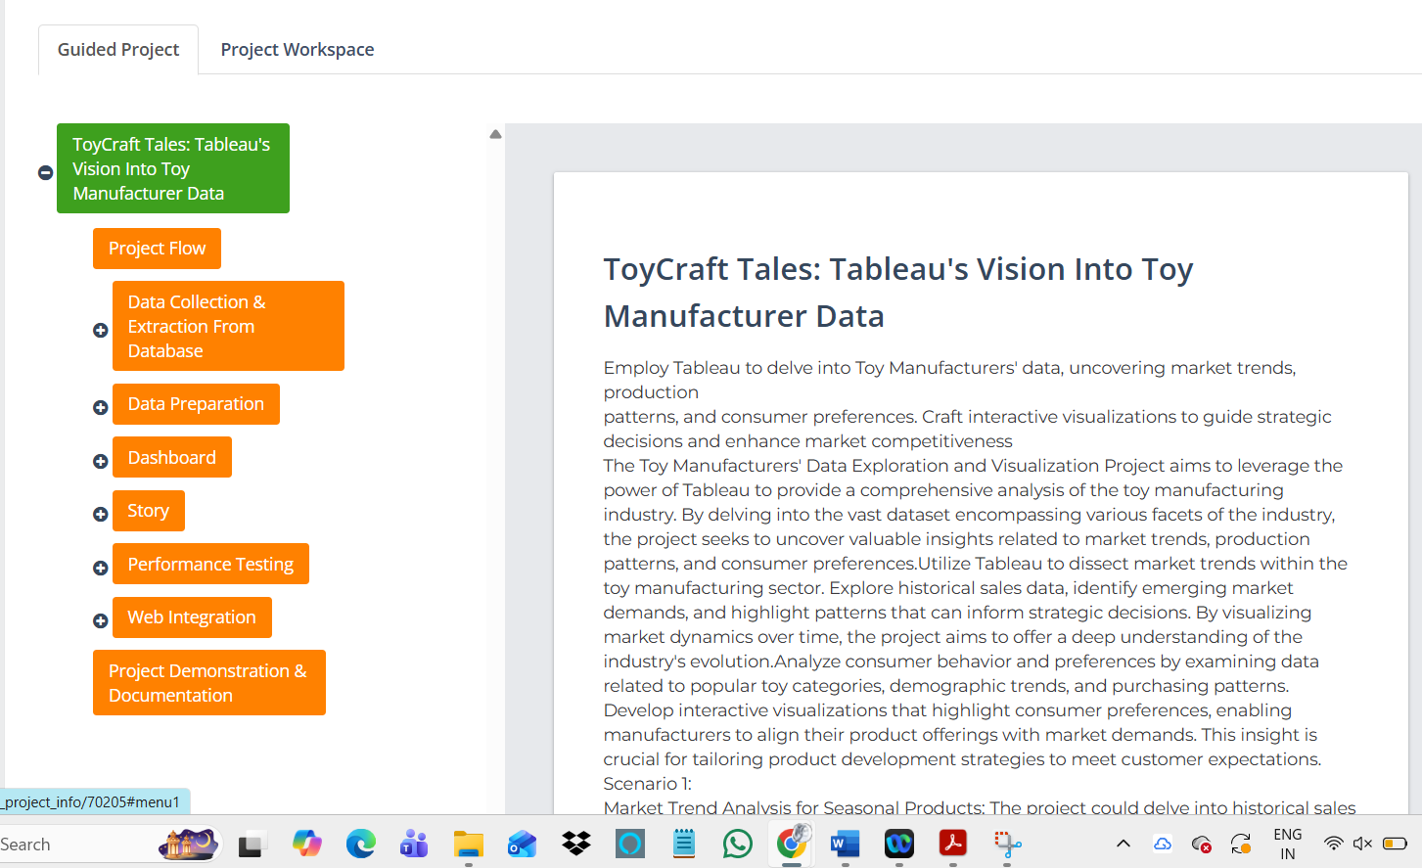
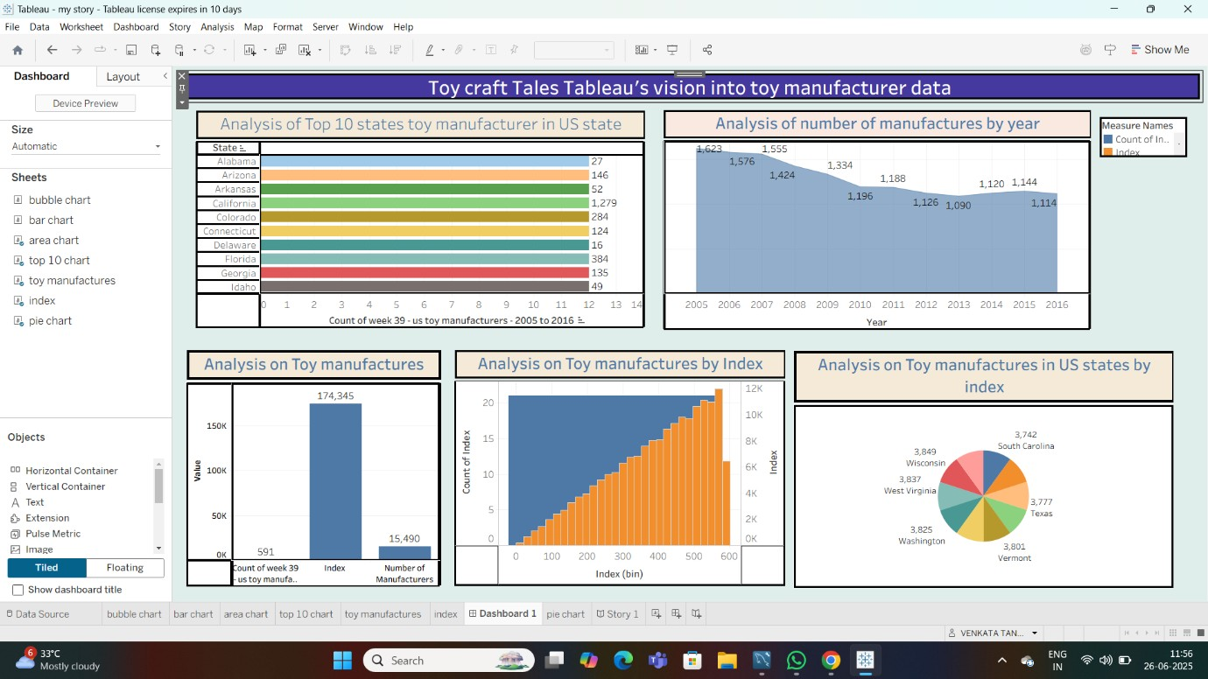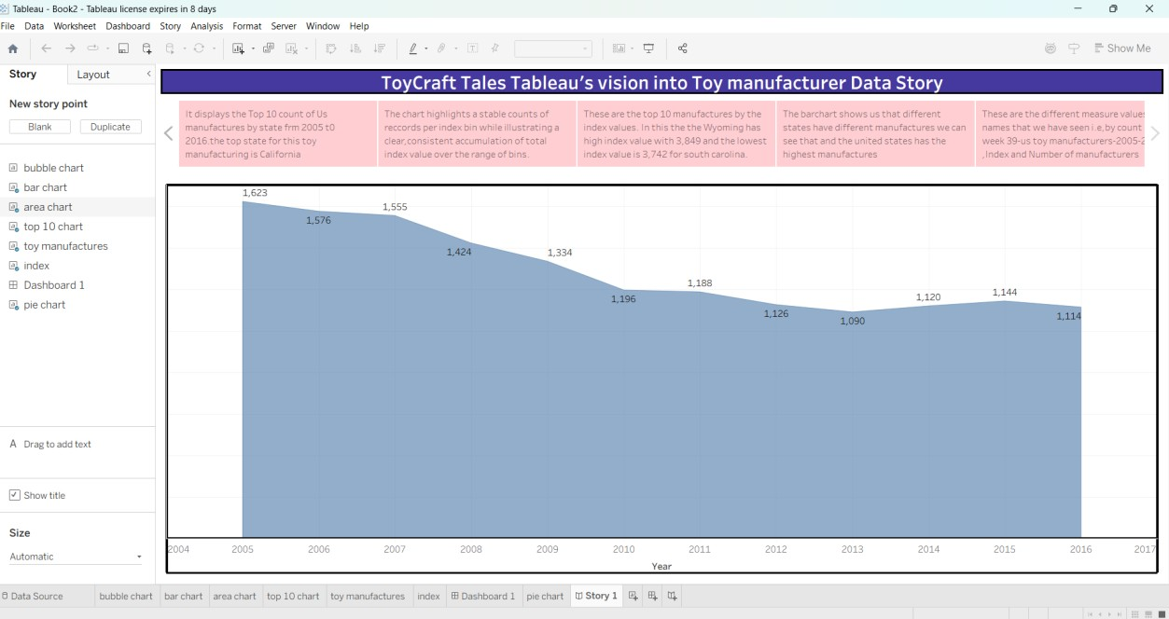
SCREENSHOT
S OF DASHBOARD AND STORY

DASHBOARD

STORY

